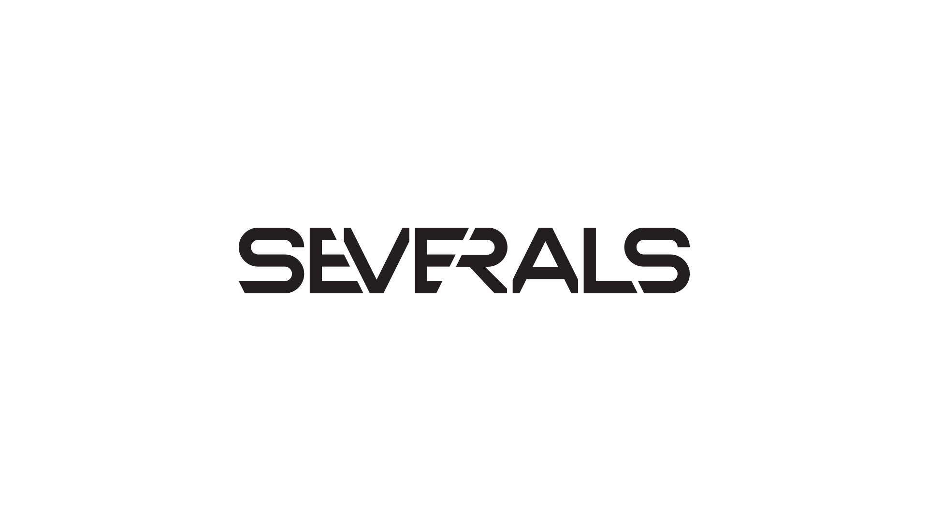

SEVERALS, an energetic four-piece band, was formed in 2015 in the heart of the Czech Republic. From the first notes, this group has become an essential part of the music scene, both at home and abroad. Their electrifying live performances and impactful studio recordings, such as the EP "Glitch" and debut album "Algorithm," initially shook up the Czech underground, but now they're drawing in international fans as well. They've racked up dozens of performances at major festivals like Rock for People, Brutal Assault, and Fajtfest, and most recently, they embarked on a tour with the cult Czech crossover-rock band The.switch. But SEVERALS aren't just about the music. They're also about the visual experience and precise execution. With their own music videos and graphics, they prove they're ready to be not only heard but also seen. Their latest album, "Algorithm," has become a hit not only at home but also in the USA and Australia. They're considered one of the most exciting and fastest-growing bands on the European metal scene. Now, following the release of the critically acclaimed single "Dejavu," the band is gearing up to showcase new material and take further significant steps in 2025. For all those seeking new experiences and the untamed power of music, SEVERALS represent an unmissable stop on the journey for extraordinary sounds and boundless energy. Join them on their endless journey!

[JOIN SEVERALS](https://www.severalsofficial.com/home)